Table of Contents
Radxa X2L Board Wiring 2
Radxa Wiring for: 3
Lesson 1 – LabVIEW “Hello World” LED On/Off 3
Lesson 2 – For Loops 3
Lesson 3 – While Loops 3
Lesson 4 – Event Structure 3
Radxa X2L Wiring for: 4
Lesson 5 – Numbers, Graphs and Charts 4
Exercise – Use DI to stop the loop 5
Analog Output (Write) 6

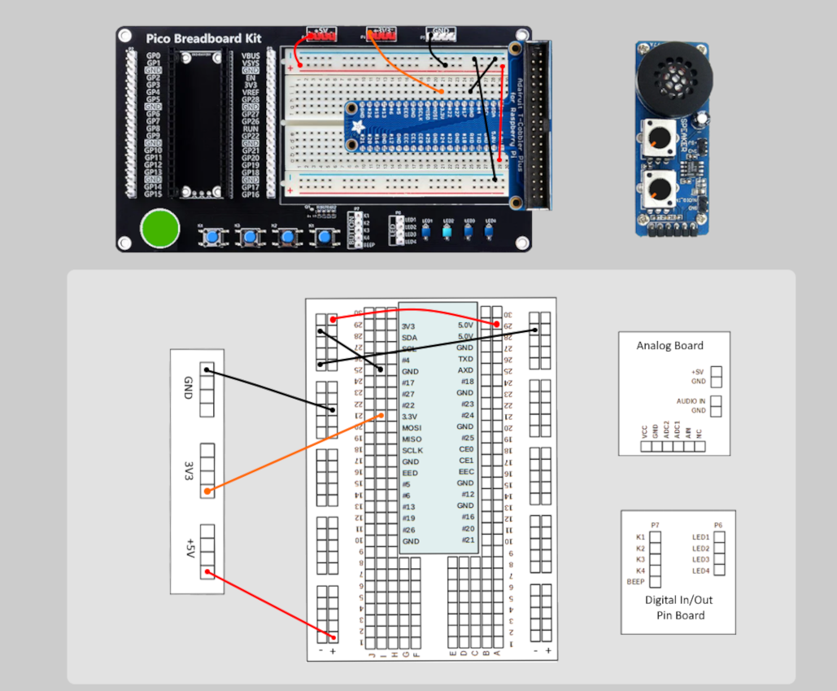
Radxa X2L Board Wiring

Radxa Wiring for:

Lesson 1 – LabVIEW “Hello World” LED On/Off

Lesson 2 – For Loops

Lesson 3 – While Loops

Lesson 4 – Event Structure
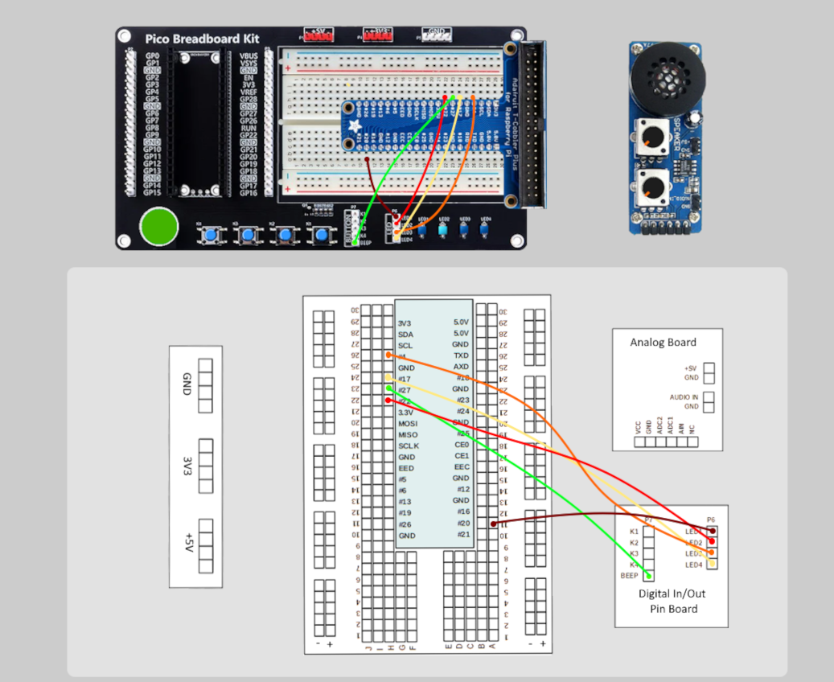
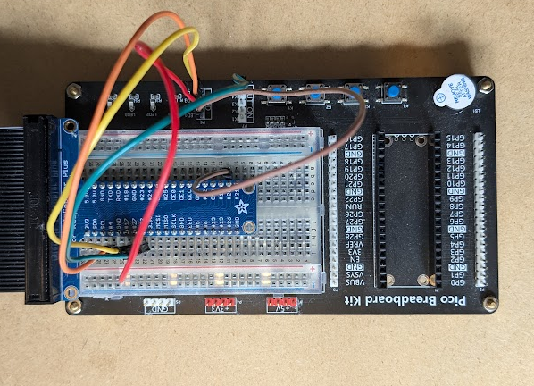

Radxa X2L Wiring for:

Lesson 5 – Numbers, Graphs and Charts
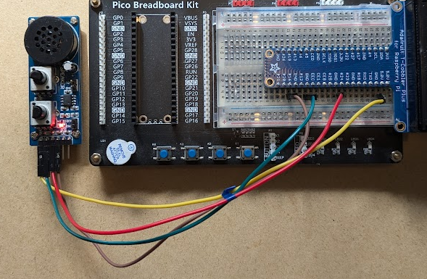
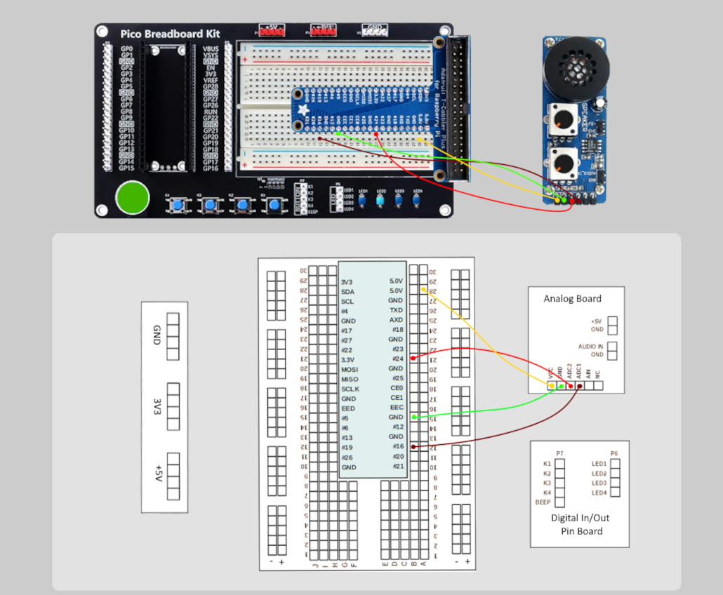

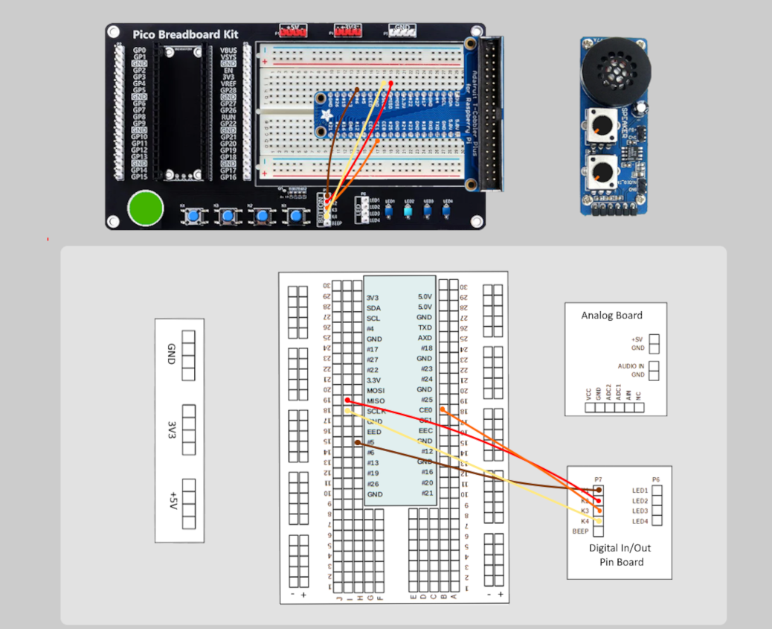
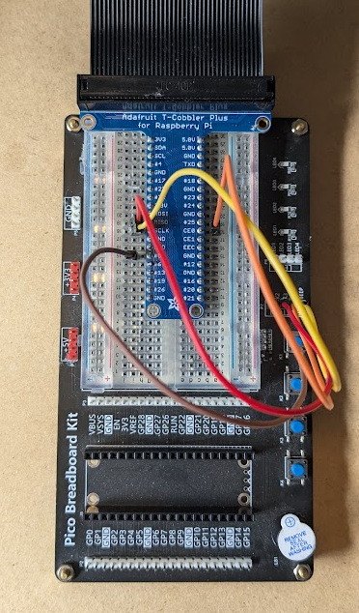
Exercise – Use DI to stop the loop

Analog Output (Write)


